Lecture 7- Relationships, Cardinality, Business Rules

**Relationships**

• A relationship is an association between entities

• A province has many patients living in it

• Each patient live in one province

• This relationship is one to many

• Each department is managed by one employee

• An employee may manage only one department

• This relationship is one to one

**Cardinality**

• The number of entity occurrences possible on the two sides of a relationship

**Cardinality Range**

• Professors teach classes

• However, sometimes there are specific ranges

• A Professor must teach at least one class, but no more than four

• Database doesn’t enforce this, must be done with program logic; this is known as a business rule

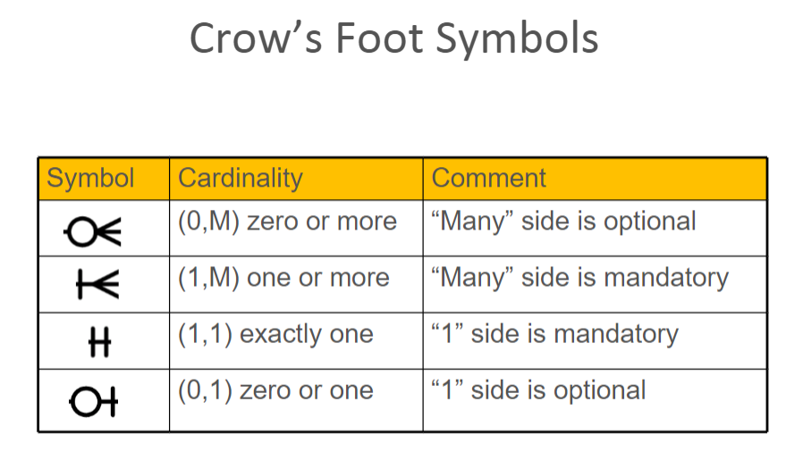

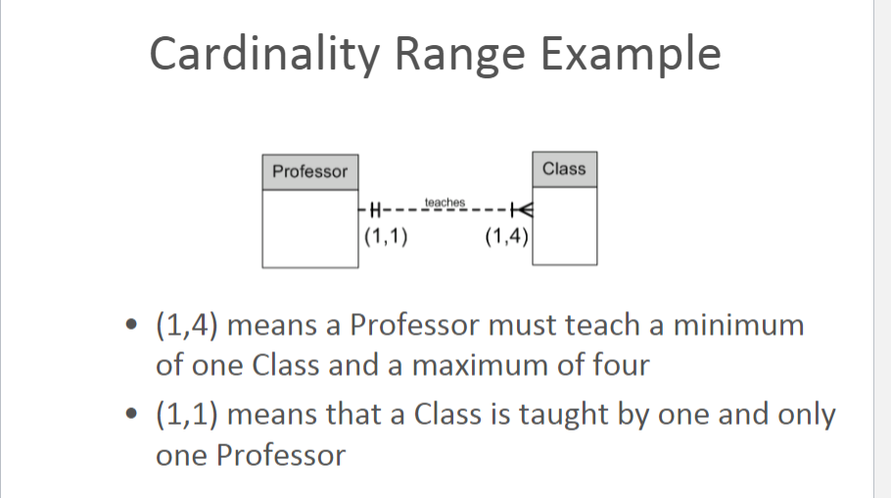

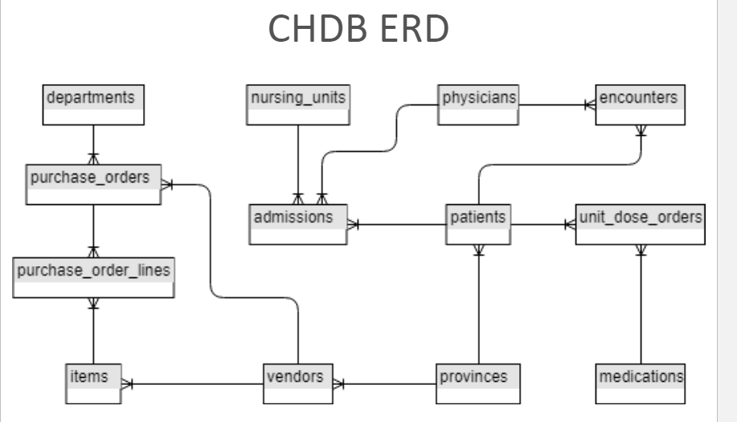

**Degree**

• A unary relationship has one entity

– Employee supervisor

– A peer-tutor program at the college

– Also known as a recursive relationship

• A binary relationship has two entities

• A ternary relationship has three entities

• A four-entity relationship has four entities

• etc.

• Ternary (and higher) relationships are usually represented by a series of binary relationships

**Relationship Examples:**

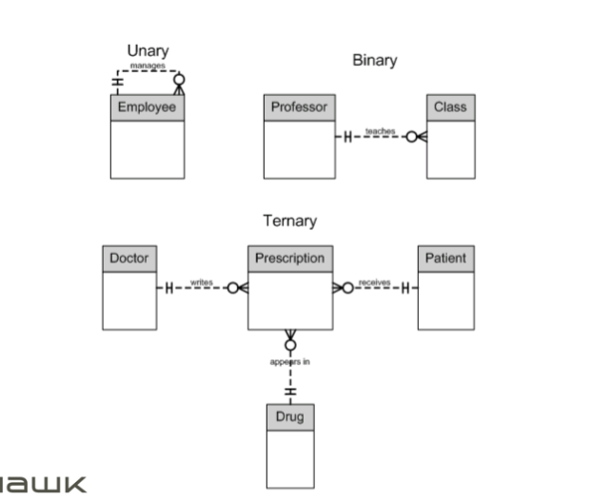

**Examples of Business Rules**

• An employee id must be unique

• A customer province must be valid

• Patient height must be greater than 0

• A machine operator may not work more than 10 hours in any 24 hour period

• Reorder items when inventory falls below 5

**What are Business Rules?**

• Specifications that preserve the integrity of a conceptual or logical data model

• Stored as part of the database

• Help standardize the company’s view of data

• Four types

**4 Types of Business Rules**

• Entity integrity

• Referential integrity

• Domains

• Triggering operations

**Entity Integrity**

• Each instance of an entity must have a unique identifier that is not null

• The primary key

**Referential Integrity**

• Rules governing the relationships between entities

• Refers to the foreign keys which link tables

• Can’t insert a purchase order for a non existent department

INSERT INTO purchase_orders

(order_date, department_id, vendor_id, total_amount, order_status)

* When FOREIGN KEY constraints are specified, typically at table creation, there is an ON DELETE and ON UPDATE parameter that specifies what action happens to rows (or columns) in a related (child) table
* The choices are NO ACTION, CASCADE, SET NULL or SET DEFAULT
* NO ACTION is the default
* NO ACTION – An error is raised and the delete/update is rolled back
* CASCADE – Corresponding rows are deleted/updated in the related table(s)
* SET NULL – Corresponding values are set to null in the related table(s)
* SET DEFAULT – Corresponding values are set to their default values in the related table(s)

Domains

* Associated with constraints that restrict the values permitted in a column
* Advantages
  + Verify values for an attribute (during INSERT or UPDATE operations)
  + Ensure data manipulation operations (joins, unions) are logical

Example: patient_height > 0

Triggering Operations

* Rules that are invoked on the action of data manipulation operations (INSERT, UPDATE, DELETE)
* Uses
  + Automatically generate derived column values
  + Prevent invalid transactions
  + Enforce complex security authorizations
  + Provide transparent event logging/auditing
  + Used as a last resort

**Triggers as a Last Resort**

* When a required business rule cannot be enforced using the following integrity
* Constraints:
  + NOT NULL
  + PRIMARY KEY
  + FOREIGN KEY
  + CHECK
* To enforce complex business rules not definable using integrity constraints

